**國立臺灣師範大學EMI TA能力測驗**

**EMI教學演示教案撰寫指引**

**親愛的EMI TA，您好**

感謝您參與EMI TA能力測驗，本測驗包含「EMI教學演示（5分鐘）」與「EMI課堂情境應對測驗（3分鐘）兩部分，全程以英語進行。本表是針對「EMI教學演示」提供教案撰寫指引，讓您實際進行教學演示時，能有更好的表現。

EMI教學演示教案表為「基本資料」、「教學設計」及「教案評估」三個部份：在基本資料部份，有概念、概念所屬領域、教材來源、學生年級、學習目標、EMI及教學策略、學生先備知識及預期挑戰與解決方案等欄位，前4項是讓評委了解您所屬的領域和想要說明的重要概念；後4項則是在設計教案時，您需要知道預期的學習目標，使用的EMI互動教學策略，學生對概念的先備知識及學生將面臨的挑戰和您的解決方式等。

在教學設計，則是將教學分成暖身、主題及回顧與評量階段，因為時間只有5分鐘，所以您需要思考時間如何安排，用什麼問題或方法確認學生具有哪些先備知識，如何清楚表達領域重要概念，及如何回顧與評量學生學習成果。接著，您可以透過教案評估，重新檢視教案是否有達到這些建議項目。

建議您在EMI教學演示時使用您學到的EMI課室語言或授課指示語，並逐步建立常用的課室語言或指示語資料庫，這樣可以使您在擔任EMI TA的過程期間更加得心應手。

最後，請您依照下列EMI教學演示教案的格式撰寫教案。

1. 教案撰寫頁數：最多4頁（不包括指引及附錄）
2. 撰寫字型：12pt.字體，Times New Roman
3. 請注意，您不能在演示過程中播放視頻或音頻片段。但是，如果你選擇在你的教案中加入這些內容，請包括片段的標題和簡短描述（1句或更短）。
4. 請返回Moodle查詢您不理解的任何關鍵術語或概念。
5. 請使用英語撰寫教案。

**祝您順利通過**EMI TA**能力測驗！**

**NTNU RCEMI EMI-TA  
培訓課程團隊 敬上**

**National Taiwan Normal University**

**The Assessment of EMI TA Skills**

**EMI Teaching Demonstration Lesson Plan Writing Guideline**

Hello EMI TA,

Thank you for participating in the assessment of EMI TA skills, which includes the EMI Teaching Demonstration (5 mins) and the EMI Course Simulation Test (3 mins), both conducted in English. This form provides guidelines to prepare your teaching plan for the EMI Teaching Demonstration section, to help you perform better during the actual teaching demonstration.

The teaching plan form is divided into three parts: Basic Information, Teaching Design, and Plan Evaluation. The Basic Information section includes fields for the concept, field, source of teaching materials, grade level, learning objectives, EMI teaching strategies, students' prior knowledge, and anticipated challenges and solutions. The first four items help the committee understand the field you belong to and the important concepts you want to explain, while the latter four items are important for designing the teaching plan, including the expected learning objectives, the EMI interactive teaching strategies used, as well as students' relevant knowledge related to the concept, as well as the challenges students may face and your proposed solutions.

In the Teaching Design section, the teaching plan is divided into warm-up, main topic, and review /assessment segments. Since there are only 5 minutes for the demonstration, you should think about how to arrange the time, how to evaluate students’ relevant knowledge, how to clearly express the important concepts of the field, and how to assess student learning outcomes. Then, you can use the Lesson Plan Self-Evaluation section to review whether the teaching plan has met these recommended targets.

We suggest that you use the EMI classroom language or instructional language you have learned during teaching demonstrations, and gradually build a database of commonly used classroom language or instructional language. This will make you more proficient during your tenure as an EMI TA.

Finally, please keep in mind the following guidelines for submitting your teaching plan:

* **Maximum** Length: 4 pages (excluding instructions and appendix)
* 12 pt. font, Times New Roman
* Please note that **you cannot play video or audio clips** during your demonstration. However, if you choose to include them in your lesson plan, please include the title of the clip and a brief (1 sentence or shorter) description.
* Return to Moodle to look up any key terms or concepts you do not understand below.
* Please be sure to write the lesson plan in English.

We wish you the best of luck in passing the assessment of EMI TA skills!

NTNU RCEMI EMI-TA Training Course Team

**國立臺灣師範大學 EMI TA能力測驗**

**EMI 教學演示教案**

**Resource Center for EMI of National Taiwan Normal University**

**EMI Teaching Demonstration Lesson Plan**

|  |  |  |  |  |  |  |  |
| --- | --- | --- | --- | --- | --- | --- | --- |
| **I. Basic Information** | | | | | | | |
| **Instructor Name** | |  | | | | | |
| **Concept** | |  | **Subject** |  | | | |
| **Teaching Materials** | |  | **Grade Level** | * Freshmen大一 * Sophomore大二 * Junior大三 * Senior大四 * Graduate研究所 | | | |
| **Learning Objectives**  **(See Appendix A)** | |  | | | | | |
| **EMI Teaching Strategies** | | Please tick the teaching strategies you plan to employ. You do not need to tick them all.   * Pre-lecture reading * Multimodal resources * Glossaries / vocabulary lists * Signposting language * Question, Think-Pair-Share, Cold Call * 3,2,1 Exit Tickets * Provide an agenda * Translanguaging * Structured group work * Inquiry-based teaching * No penalty reattempt assessments * Other: | | | | | |
| **Student Prior Knowledge** | | List no more than 2 concepts your students will be expected to know in advance: | | | | | |
| **Anticipated Challenges and Solutions** | | Briefly explain one anticipated challenge and your solution:   1. Challenge: ; Solution: 2. Challenge: ; Solution: | | | | | |
| **II. Teaching Design** | | | | | | | |
| **Item** | **Procedure** Note: The terms *instruction* and *activity* are included only as a general guide. It is not necessary to include both steps for every item section. Please include only as relevant for your lesson plan’s specific concept, field, and learning objectives. | | | | **Time** | **Teaching Resources**  **(ex: PPT, Photo, etc.)** | |
| **Warm-up** | **Instruction**  **Activity** | | | |  |  | |
| **Presentation** | I **Instruction**  **Activity** | | | |  |  | |
| **Review**  **& Assessment** | **Instruction**  **Activity** | | | |  |  | |
| **III. Lesson Plan Self-Evaluation** | | | | | | | |
| **Check Item** | | | | | | | **Tick If Completed.** |
| Before designing the teaching concept, I clearly evaluated students' prior knowledge to reduce learning barriers for them. | | | | | | |  |
| When planning my instruction and activities, I anticipated what challenges my students might face during class and came up with solutions to help them achieve the learning objectives. | | | | | | |  |
| When designing teaching topics, I paid attention to using English that is easy to understand. | | | | | | |  |
| After students have completed this course, they should be able to achieve the learning objectives set out in this lesson plan. | | | | | | |  |
| During the teaching process, I have timely used **Classroom English** and **Signposting Language** to assist students in understanding the course content. | | | | | | |  |
| I have utilized the expected EMI Teaching Strategies during my teaching demonstration. | | | | | | |  |

**Appendix A**

When creating your lesson objectives, you can use Bloom’s Taxonomy to help decide your exact expected outcomes for your students. For more information about Bloom’s Taxonomy, please see the University of Arkansas’ website, Teaching TIPS: <https://tips.uark.edu/using-blooms-taxonomy/>.

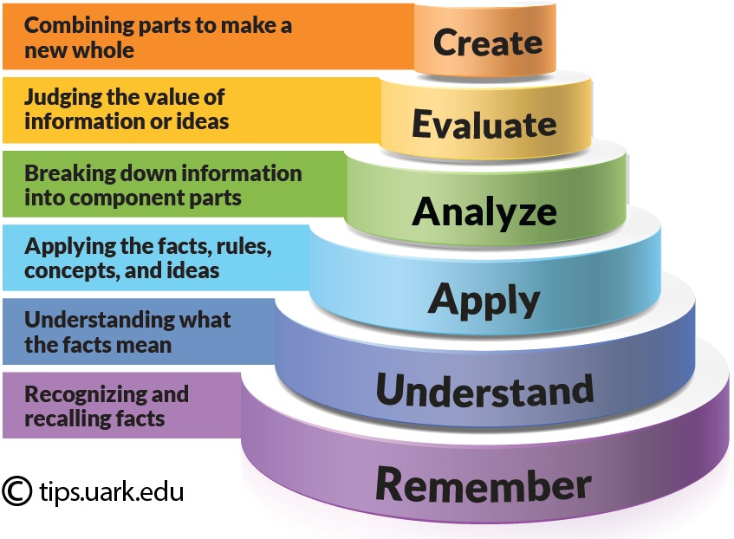

Image source: Shabatura, J. (2022) “Using Bloom’s Taxonomy to Write Effective Learning Outcomes” *Teaching TIPS.* University of Arkansas. URL: <https://tips.uark.edu/using-blooms-taxonomy/>