國立臺灣師範大學EMI TA專業知能培訓課程
EMI教學演示教案撰寫指引
親愛的同學，您好
感謝您參與 EMI TA 線上培訓課程! 我們很高興您選擇繳交教案，無論是因為個人成長（方案一）還是參加 EMI TA 能力測驗（方案二或三），以下撰寫指引將協助您撰寫一份教案。另外，參加EMI TA能力測驗者，也請遵循以下有關教學演示的提醒。
EMI教學演示教案包括基本資料、教學設計及教案評估三個部份：
在「基本資料」部份，有概念、概念所屬領域、教材來源、學生年級、學習目標、EMI教學策略、學生先備知識及預期挑戰與解決方案等欄位，前4項是說明您所屬的領域和想要教授的重要概念；後4項則是在設計教案時，您需要知道預期的學習目標，使用的EMI互動教學策略，學生對概念的先備知識及學生將面臨的挑戰和您的解決方式等。
在「教學設計」部份，是將教學分成暖身、主題內容傳遞及回顧與評量等三個階段，您需要思考時間如何安排，如何清楚表達領域重要概念，如何與學生互動以促進學習，及如何回顧與評量學生學習成果。
完成教案後，您可以透過「教案評估」，重新檢核教案是否達到這些項目。你的教案(初版)繳交後，我們將請審查老師以與教案檢核相同項目來進行審查。不論參與哪一種方案，皆可選擇是否再寄回修改教案(二版)給中心，換言之，即寄回參考審查老師建議的修改教案給中心，讓你清楚知道自己是否在進步，變得更好。
最後，請您依照下列格式撰寫教案：
- 教案撰寫頁數：最多4頁（不包括指引及附錄）。
- 請返回Moodle查詢您不理解的任何關鍵術語或概念。
- 請使用英語撰寫教案。

以下是針對參與EMI TA能力測驗同學（方案二或三）的提醒
- 請準備一份教案簡報(PowerPoint)進行教學演示。
- 請注意，您不能在演示過程中播放視頻或音頻片段。但是，如果您選擇在您的教案中加入這些內容，請包括片段的標題和簡短描述（一句或更短）。
- 因為演示時間只有5分鐘，可選擇演示其中一或二個階段，並請在教案使用藍色的文字來標示（詳見教案範例）。
- 建議您在教學演示時使用EMI課室語言或教學語言。

祝您教案撰寫順利！
NTNU RCEMI EMI TA
培訓課程團隊 敬上
National Taiwan Normal University
EMI TA Professional Development Program
EMI Teaching Demonstration Lesson Plan Writing Guideline

Hello students,

Thank you for participating in the EMI TA Professional Development Program! We are thrilled that you have chosen to complete a lesson plan, either for your own personal growth (Plan 1) or to participate in the Assessment of EMI TA Skills (Plan 2 or 3). In all cases, the following instructions can help you make the most out of your lesson planning activity. Those who will submit their lesson plan as part of their Assessment of EMI TA Skills should be sure to follow the advice below carefully.

The teaching plan form is divided into three parts: Basic Information, Teaching Design, and Plan Evaluation. The Basic Information section includes fields for the concept, field, source of teaching materials, grade level, learning objectives, EMI teaching strategies, students' prior knowledge, and anticipated challenges and solutions. The first four items establish the field you belong to and the important concepts you want to explain, while the latter four items are important for designing the teaching plan, including the expected learning objectives, the EMI interactive teaching strategies used, as well as students' relevant knowledge related to the concept, the challenges students may face, and your proposed solutions.

In the Teaching Design section, the teaching plan is divided into three segments: warm-up, content delivery, and review / assessment. Since there are only 5 minutes for the demonstration, you may choose to focus on only one section. While planning, you should think about how to arrange the time, how to interact with students to facilitate learning, how to clearly express the important concepts of the field, and how to assess student learning outcomes. After completing the lesson plan, you can use the Lesson Plan Self-Evaluation section to review whether the teaching plan has met the recommended targets. The committee will evaluate your lesson plan based on these same targets.

Finally, please keep in mind the following guidelines for submitting your teaching plan:
- Maximum Length: 4 pages (excluding instructions and appendix)
- Return to Moodle to look up any key terms or concepts you do not understand.
- Please be sure to write the lesson plan in English.

The following is a reminder for Assessment of EMI TA Skills participants (Plan 2 and 3):
- Please prepare a PowerPoint to assist your teaching demonstration.
- Please note that you cannot play video or audio clips during your demonstration. However, if you choose to include them in your lesson plan, please include the title of the clip and a brief (1 sentence or shorter) description.
- If choosing to focus on only one section of the lesson plan, please indicate by writing in blue color text for the relevant section(s).
- We recommend to use classroom English and EMI instructional language during your demonstration.

We wish you the best of luck in passing the assessment of EMI TA skills!

NTNU RCEMI EMI TA Training Course Team
國立臺灣師範大學 EMI TA能力測驗
EMI 教學演示教案
Resource Center for EMI of National Taiwan Normal University
EMI Teaching Demonstration Lesson Plan
I. Basic Information
Instructor Name
Concept |  |  | Subject
Teaching Materials |  |  | Grade Level | - Freshmen大一  - Sophomore大二  - Junior大三  - Senior大四  - Graduate研究所
Learning Objectives
(See Appendix A)
EMI Teaching Strategies |  | Please tick the teaching strategies you plan to employ. You do not need to tick them all.  - Pre-lecture reading  - Multimodal resources  - Glossaries / vocabulary lists  - Signposting language  - Question, Think-Pair-Share, Cold Call  - 3,2,1 Exit Tickets  - Provide an agenda  - Translanguaging  - Structured group work  - Inquiry-based teaching  - No penalty reattempt assessments  - Other:
Student Prior Knowledge |  | List no more than 2 concepts your students will be expected to know in advance:
Anticipated Challenges and Solutions |  | Briefly explain one anticipated challenge and your solution:  - Challenge: ; Solution:
II. Teaching Design
Item | Procedure  Note: The terms instruction and activity are included only as a general guide. It is not necessary to include both steps for every item section. Finally, please remember to use blue text for the section(s) you choose to include in your teaching demonstration. |  |  |  | Time  Total:  5 min | Teaching Resources  (ex: PPT, Photo, etc.)
Warm-up | Instruction  Activity
Content Delivery | I Instruction  Activity
Review  & Assessment | Instruction  Activity
III. Lesson Plan Self-Evaluation
Check Item |  |  |  |  |  |  | Tick If Completed.
My expectations for students’ prior knowledge, anticipated challenges and proposed solutions are appropriate for the course’s concept, field and grade level.
My selected teaching materials are appropriate for the learning objectives and are implemented in the teaching design.
The lesson’s learning objectives are reflected in each section of the teaching design.
My selected EMI teaching strategies are explicitly referenced in the teaching design.
The warm-up, content delivery, and review / assessment sections of my lesson plan are related to each other and the learning objectives.
My plan for content delivery is interactive, and integrates several EMI teaching strategies to support students.
The review/assessment section highlights knowledge or skills outlined in both the lesson’s learning objectives and content delivery.
Appendix A
When creating your lesson objectives, you can use Bloom’s Taxonomy to help decide your exact expected outcomes for your students. For more information about Bloom’s Taxonomy, please see the University of Arkansas’ website, Teaching TIPS: https://tips.uark.edu/using-blooms-taxonomy/.

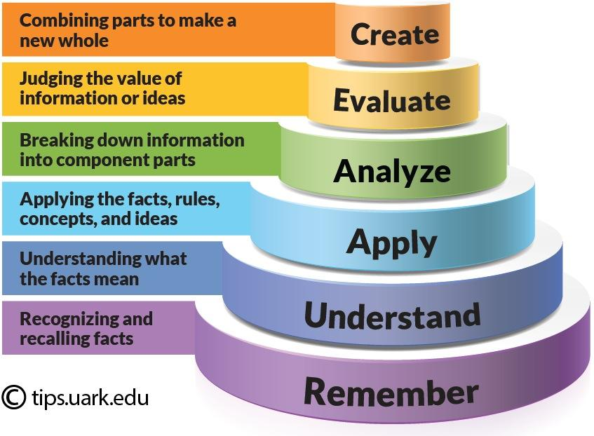
Image source: Shabatura, J. (2022) “Using Bloom’s Taxonomy to Write Effective Learning Outcomes” Teaching TIPS. University of Arkansas. URL: https://tips.uark.edu/using-blooms-taxonomy/

